|  |
| --- |
| By Cliff Rodriguez |
| Problem Set 3 |
| Econ 4811  Date: due Feb 28, 2018 |

|  |
| --- |
| Rodriguez, Cliff |

Contents

**No table of contents entries found.**

**No table of figures entries found.**

# Question 1

1. 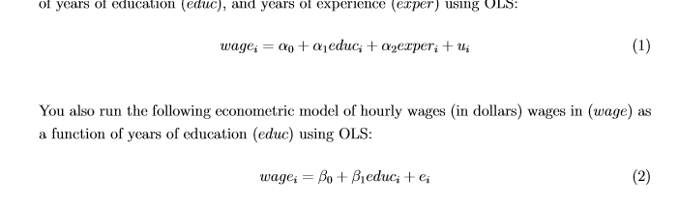

= .65

Interpretation: For an additional year of education wage is expected to increase by $650, with experience held constant.

= .07

Interpretation: for each additional year of experience wage is expected to increase by $70, with education held constant.

= .55

Interpretation:

For each additional year of education hourly wage is expected to increase by 55 cents.

1. All else held constant, an individual with an additional three years of experience will have a difference in wage of $210. The difference in wage is expected because = .07.
2. All else held constant a person who has five more years of education is expected to have a wage difference of $3,250. The difference in wage is expected because = .65.
3. Say something about The correlation between educa and exper ….
4. Graph estimated relationship between education and wages for the entire sample
5. Graph education and wages for people that have 10 years of experience.
6. Because is greater than , is biased. This would result in a higher slope of the line, making it over
7. BLUE analysis

For the values to be the same there are two possible cases:

* The partial effect of x2 on yhat is zero in the sample (bs hat = 0)
* X1 and x2 are uncorrelated and

# Question 2

(i)

(ii)

(iiii)

(iv)

(v)

# Question 3

1. Get from notes

# Question 4

# Question 5